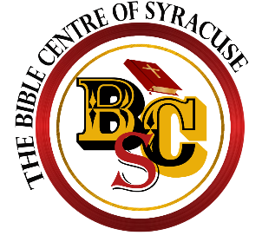
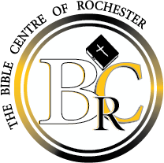
THE BIBLE CENTRE OF ROCHESTER/SYRACUSE
Post Office Box 30787
Rochester, New York 14603
585-502-8330
www.bcroc.info
www.biblecsyracuse.com

II Timothy 2:15 - "Study to shew thyself approved unto God, a workman that needeth not to be ashamed, rightly dividing the word of truth." KJV

Student Admissions and Registration Form Bachelor Program

Full Name:

Social Security Number: Date of Birth:

Mailing Address:

Telephone Number: ( )

E-Mail Address:

Comments: All student materials and information are to be forwarded to the address listed above

Full Tuition for Course, Lab fees, & Bible Centre Cost is $3600.00 The discounted tuition cost for continuing students who have earned a Bible Centre Associate in Christian Ministry is $3,100.00.

As student can complete the bachelor program at an enhanced rate of 20 – 24 months. All bachelor students are required to pay a $50 non-refundable application fee. There is a $250 reduction off of the entire tuition if paid in full on the first day of class and a $150 reduction if tuition is paid in full within 30 days of the start of class. If a student is unable to pay the full tuition, upon acceptance, $150 of the balance is due the first day of class with the option to pay the full tuition within 30 days for the $150 reduction or pay the remaining balance over a period of 17 - 19 months at $175 per month depending on your cost. (Note: Late monthly tuition payments are subject to a $25 late charge per month that monthly tuition is not paid.)

Monthly Installment Payment Plan

To take advantage of the monthly installment plan, students must contact the Bible Centre Office of Student Financial Services to obtain and execute an agreement. Agreements must be executed prior to the first day of class instruction. A monthly installment payment of $175.00 dollars minimum is accessed for each monthly installment payment. Failure to pay as agreed subjects the student to a late payment fee and possible cancellation of his/her class schedule for the term. A student cannot graduate until all financial responsibility is satisfied.

The Student enrolling in this course fully understands that once he/she is officially registered by the Bible Centre of Rochester or Syracuse that tuition refunds in part or in full will only be refunded under conditions stated and adopted as policy in the Bible Centre Student Handbook. The student also understands that once enrolled that they may complete the course in their own leisure up to 4 years from receipt of the Bachelor course and may graduate with Bible Centre students once the course materials have been completed. Under no circumstances will a refund of the $50 application fee be given.

All initial payments are non-refundable regardless of completion of the course.

I have read and understand the guidelines presented regarding tuition payments to the Bible Centre and I agree.

Student Signature Date of Enrollment
(ElectronicsSignature is acceptable)

Office Use Section – Do not write below this line

Student Name:

Date of Enrollment:

Application Fee: $

Method of Payment: Cash Check # Credit Card (underline One)

Student will: ___Pay tuition in full by first day for $250 reduction

___ Pay Tuition in full within 30 days after class for $150 reduction*

___Pay $175 per month for months*

*Requires $175 down on first day of class

